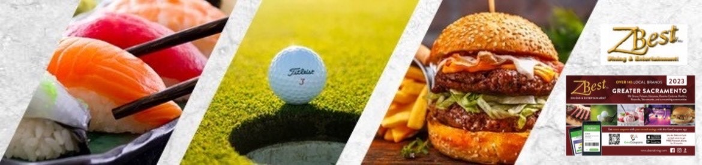

Hi

Thank you for your interest in our ZBest Dining & Entertainment Coupon Book program.

Below are some the key points that make ZBest Dining & Entertainment Coupon Books a fabulous fundraiser:

* **PROFITABLE: 40% Profit Per Coupon Book ( $10)**
* **SIMPLE:** ZBest will provide each participant with a sales packet which includes a ZBest Coupon Book, an Order Form and Parent Letter on consignment for a sales period with a no hassle delivery!
* **FREE BOOKS**: Individual participants will earn 1 free book for every 5 books sold.
* **QUICK:**  3 week fundraiser (includes delivery)
* **SALES PRICE**:- ZBest Dining & Entertainment Book $25.00/ Your Cost - $15.00

Our customers consistently tell us that their ZBest Dining & Entertainment Coupon Book fundraiser is the easiest fundraiser they have ever run.

|  |
| --- |
| [**Click Here to Sign Up Today!**](http://www.zbestfundraising.com) |

 Let me know if you have any questions.  We look forward to hearing from you.

Susan Pack

**ZBest Fundraising**

10300 Pleasant Grove School Rd

Elk Grove, CA 95624

(916) 708-6809 cell

(916) 686-1555 office & fax

(844) 74ZBEST ( 844) 749-2378 toll free

[Join Our Mailing List for Easy Fundraising Ideas](https://nam02.safelinks.protection.outlook.com/?url=http%3A%2F%2Fvisitor.r20.constantcontact.com%2Fd.jsp%3Fllr%3Dg96putwab%26p%3Doi%26m%3D1123792975686%26sit%3D8t9qttlkb%26f%3Dbe82d8f5-850b-40f6-b5d5-dd20882ed71b&data=04%7C01%7CRKeup%40egusd.net%7C68352ffe613e454fb35708d93a7d3c30%7C03d4d9960f8144c68dc6f3e24a9a5ded%7C0%7C0%7C637605132733701199%7CUnknown%7CTWFpbGZsb3d8eyJWIjoiMC4wLjAwMDAiLCJQIjoiV2luMzIiLCJBTiI6Ik1haWwiLCJXVCI6Mn0%3D%7C1000&sdata=bsOnywlMTcTLFy4jEyOjJ%2BobAeH0PGUMBec2rbLdUGg%3D&reserved=0)

