ORDER TODAY!
Purchase delicious
Butter Braid® Pastries and
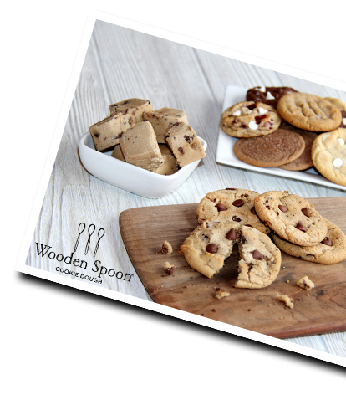
Premium Cookie Dough
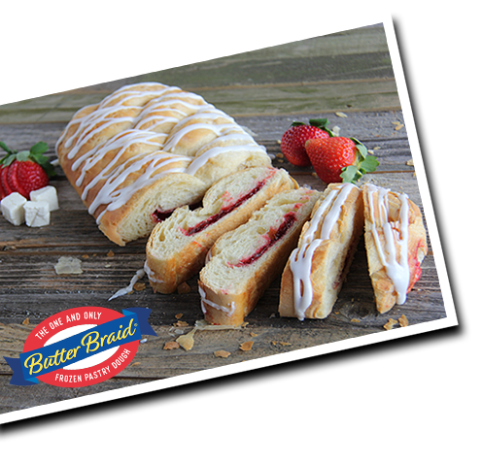
through our fundraiser!

Don't forget to contact
your family and friends!
Thank you for your support!!

