As you start to see online sales come in, you will also likely get some emails/calls from supporters hoping to adjust their orders.
Common requests:
- Change my seller
- Refund my order
- I accidentally ordered 2 instead of 1
Supporters are able to make these changes themselves by clicking the View Order button in their confirmation email.
If they want you to make changes to their order, simply ask the supporter to forward their order confirmation email to you. From there, you can click View Order and then scroll down to make the requested changes.
If they want to swap one flavor for another, simply refund the item they don’t want and then have them place a new order for the other item. (They’ll have to pay the convenience fee again.) This is the only way to swap one flavor for another.
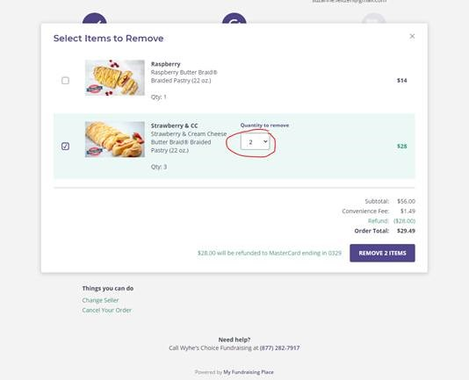
If you get stuck, we’re just an email away. Send your questions to support@myfundraisingplace.com and we’ll be happy to help.

