ORDER TODAY!
Purchase delicious Butter Braid® Pastries through our fundraiser!
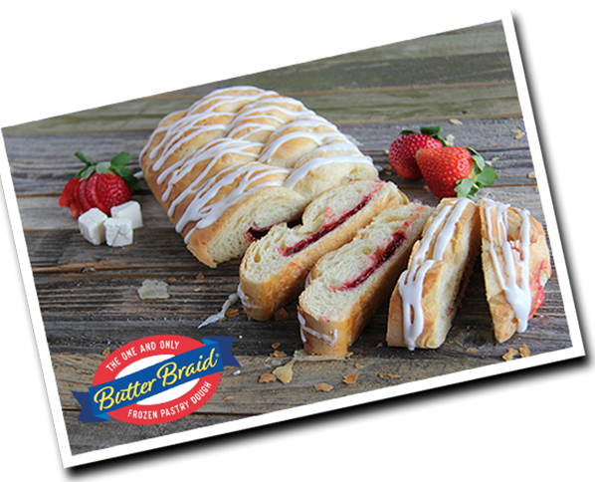

Don't forget to contact
your family and friends!
Thank you for your support!!

